HAND EMBROIDERY CAMP
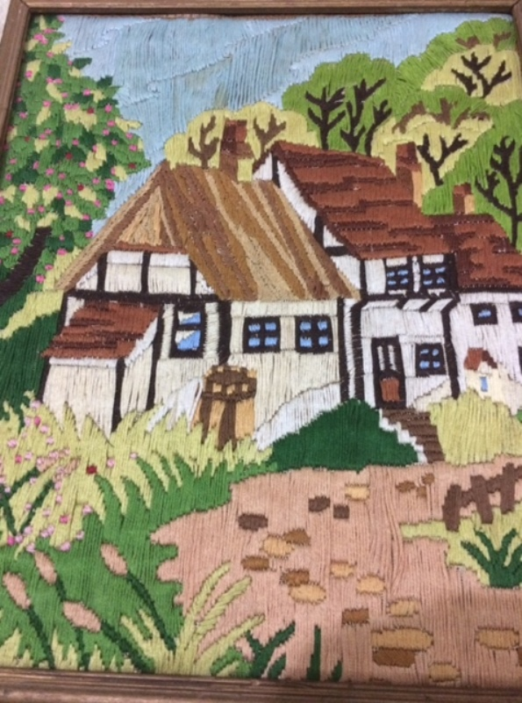
The art of embroidery is decades old but still popular.
Kids will learn a number of basic embroidery techniques.
The fabric is your canvas for expressing your thoughts, and dreams using needle and thread.

Note: The class will consist of small groups. Register ASAP as space is limited

